Total number of lines of code that belong exclusively to Ron: 24665, that is no white space or autogenerated code is: that is not including the web app, services called, or any web or Desktop Application code.
The total project code written by Ron plus his choice of .NET 1.1 generated code is 36050 which is an underestimate (given by analysis of the Code Lines code analysis application).
The total needed to do it the right way for all Ussco apps is approximately 21050 that is including every Ussco app, including work by John, Eric, Ron, and new features to the code. Take away that Core Api written by Matt Ruggio does the PDF rendering as a web service and Core Rendering is reusable for current iterations it leads to a dramatic decrease in lines of code.
The code for the USSCo automated apps only can be 16550 as an over estimate due to a centralized core and Data Layer.
And thinking of the difference between hooking in Core Rendering versus Abp that adding another method to Core Api means that many more lines would be saved.
Package Structure Overview
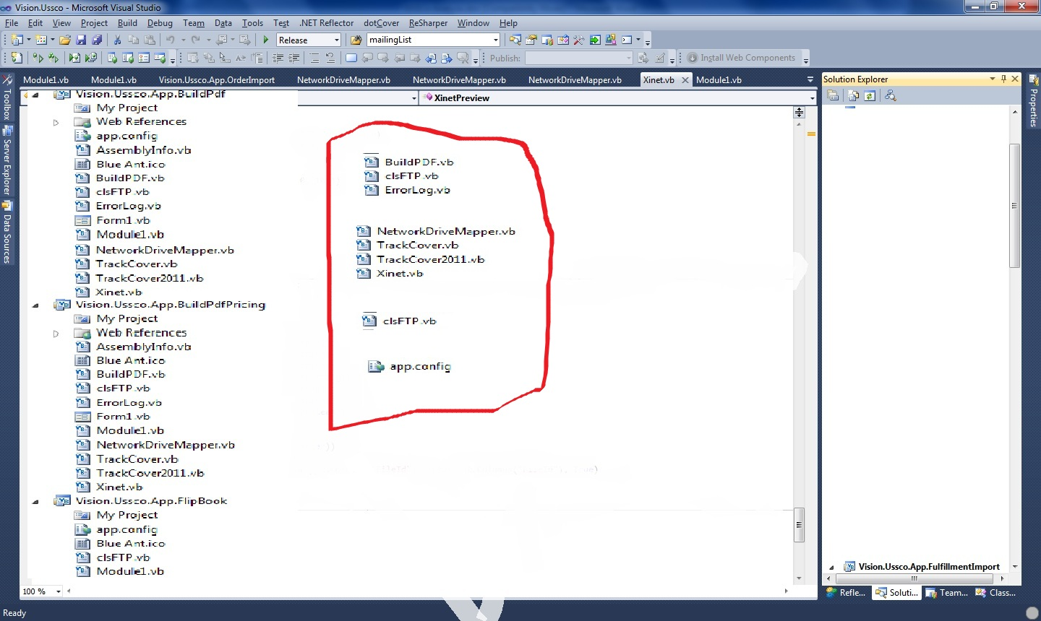
As you can see, the files in red are duplicated in many places. If say, Xinet.Vb or any of them were changed all of the 5 Xinet.vb files would have to be changed leading to added development time and therefore added cost.
Duplicate code is also prone to error which means that if it was copied the wrong way or if the fact that the code is very fickle and delicate that the patch breaks something else then the code would have to be modified again in multiple spots.
Here is a function used a lot in the code: getSchema() it returns a text file as a DataTable. Simple enough but copied 5 times leading to inconsistencies upon update.
Here is another example: Send Email() and ErrorLog.vb, they are in every file and the difference between ErrorLog.vb files and SendEmail methods is you guest it: a single string message.Subject = “”;
How fickle and delicate is the code?
You will see this everywhere:
For All Rows in a DataTable
For all Columns in a Row
Row(i) = sData(i)
It simply copies the data from a collection to a table in the database. One problem, it is not strongly typed. Suppose it were: sData(i).ToString() the method no longer works in some cases.
The program uses DataSets everywhere, magic strings determine what the values are and no one understands why the name was chosen except Ron. No one can think of all the edge cases that DataSet to an ORM might happen except Ron and by the look of the code if it is not an Object then it will break because the code is so strongly tied to the dynamicness of an Object being anything in a dataset.
The code will also be almost the exact same except 1 to 5 conditional statements as in BuildPDF for BuildPDF old and BuildPDF_Pricing .
There is no documentation or helpful comments and the comment ‘was added on #SomeDate# For Reason Two word Reason which is nothing to do with the code style or application choice is not a good enough comment.
Source Control:
There wasn’t any and now the .NET 4.0 solution is in GitHub.
Unit Testing:
There is none and Unit Testing is the core to ensuring the code works even after and during development so when we eventually make changes we can test if anything broke which ensures backward compatibility and lessens cost of mistakes.
Environments:
Ron was developing on the live server and the code was up for grabs because it was not deployed code but real vb.NET source files which means if someone broke into the server or hacked in they could change the site live.
Architecture and 3 Tiered Applications:
This allows for quicker development if there is a separate layer for application logic, presentation and database access but as it is there is no change in architecture and everything is thrown into a file Module1.vb file that uses duplicated files and code from every solution: it is obtuse and just thrown together to work as a sequentially and procedural based executed program.
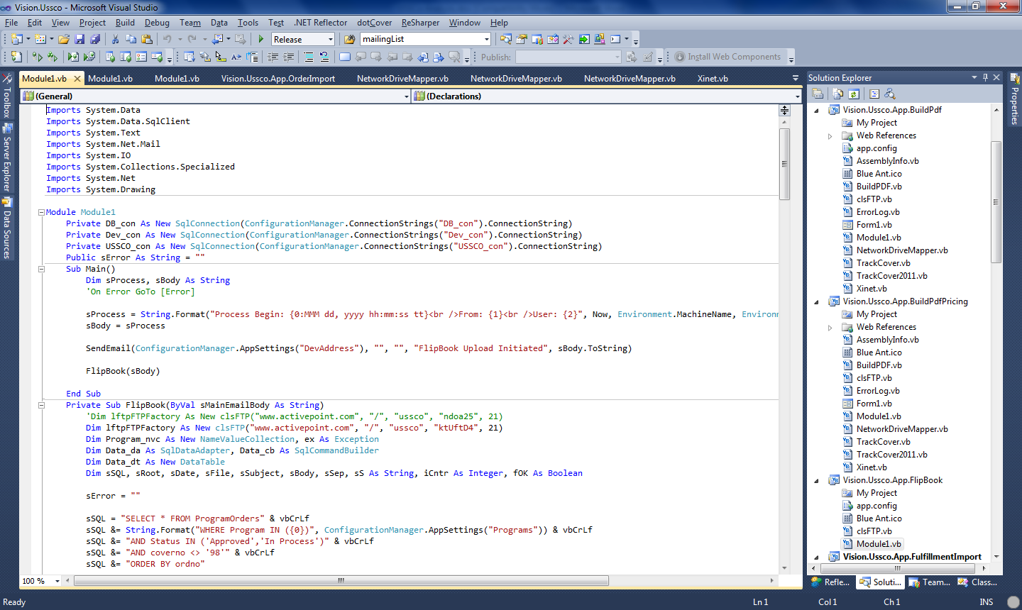
Here is module1.vb for the flip book app:
- Start in Main
- Call some Sub that does something by using ftp and datasets and send a bunch of emails then exit the program.
And that sequence repeats constantly.
Coding Standards:
No coding standards appear to exist. It is recommended that coding standards be created, implemented, and enforced (with scheduled and documented code reviews).
There is no documentation or coding standards used even in naming variables example: sData, sHour, and so many more.
Code Tracking:
This allows for version tracking in case of rolling back to avoid messing up the code: I have no idea how the code looked with each change Ron made because I only have access to the latest code.
Data Base:
Because the Data Base is not normalized: I ran a Test and there exist an app called: USSCoProofExport which takes over 15 minutes to run because of the large data being returned from non-normalized tables. The ProgramOrders table is massive and is the main table used by every app however it is duplicated and called AdvOE in a separate database used by the apps.
In fact Data is everywhere and there are three databases, which are not transactional so if there was an error in the code it would lead to inconstancies and because it is on SQL Server 2000, transactions cannot be done in the code and that leads to many problems that could arise if we tried to optimize the code.
In-Depth Look:
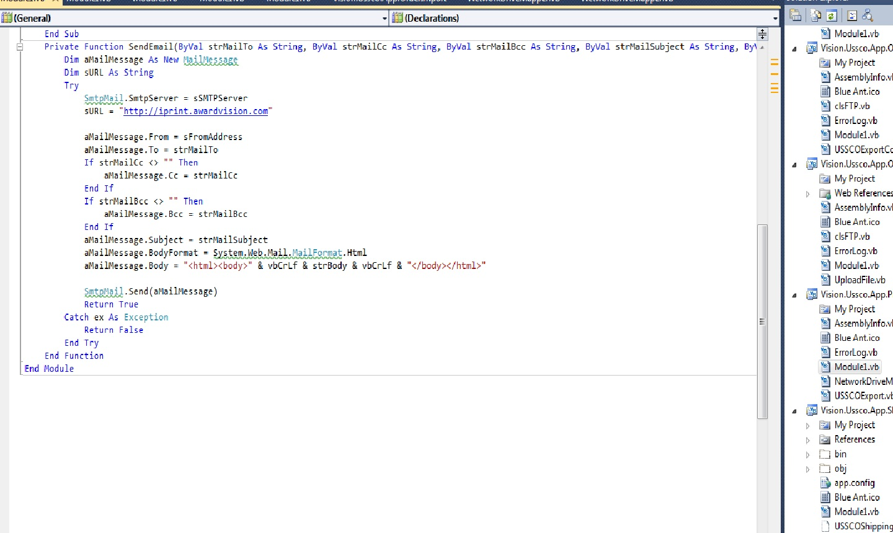
And Look at this:
<appSettings>
<add key="SMTPServer" value="smarthost.awardvision.com"/>
<add key="FromAddress" value="iprintmail@visionps.com"/>
<add key="FromDisplay" value="Load Flag Import"/>
<add key="ToAddress" value="jjohnson@visionps.com,jbertucci@visionps.com"/>
<add key="CcAddress" value="jjarsombeck@visionps.com,jmaziarka@visionps.com,dhir@visionps.com,bcarver@visionps.com,judy.ezell@worldcolor.com"/>
<add key="BccAddress" value="rradkay@visionps.com"/>
<add key="ErrorAddress" value="rradkay@visionps.com"/>
<add key="DevAddress" value="rradkay@visionps.com"/>
<add key="URLLocation" value="http://iprint.awardvision.com"/>
<add key="FTPLocation" value="\\Awardwb01\ftproot\quebecor"/>
<add key="ProcessLocation" value="\\Awardfp01\Composition\Upload\Quebecor\"/>
</appSettings>
<connectionStrings>
<add name="DB_con" connectionString="server=AwardDB01;uid=iPrint;pwd=Award;database=UnitedStationers;"
providerName="System.Data.SqlClient" />
<add name="USSCO_con" connectionString="server=AwardDB01;uid=iPrint;pwd=Award;database=USSCO;"
providerName="System.Data.SqlClient" />
<add name="Dev_con" connectionString="server=AwardDB01;uid=iPrint;pwd=Award;database=Dev;"
providerName="System.Data.SqlClient" />
<add name="iPac_con" connectionString="server=AwardDB01;uid=iPrint;pwd=Award;database=iPac;"
providerName="System.Data.SqlClient" />
</connectionStrings>

Most of these key value pairs exist in every single app.config. If one were to change all the solutions would need to change.
Send Mail is everywhere with different subjects.
Solutions to the problems:
I suggest this:
- All code that helps the business logic and the datasets needs to be refactored and centralized
- There needs to be three testable layers for the business logic (a 3 tiered architecture) which will be known as Vision.Ussco.Core. It will contain all common code between the applications as well as the main part of the logic and code that is only different slightly will be fixed by various software design patterns that will be tailored to fix the small differences.
- The Vision.Ussco.Core will likely account for 75% of the code and allow for code separation.
- This is not achievable in one fail swoop due to edge cases that are handled by the fragileness of Ron’s code.
- I suggest an iterative approach. Ussco is in .NET 4.0 in VB.NET 2002 syntax, it will take many iterations like WFC has gone through to move to the modern architecture
- The modern architecture allows for full testability and easy maintenance which means adding new features or changes to the rapidly growing Ussco logic will be easier.
- Why we cannot simply redo it in a single iteration? Because there exists such a dependency of everything on everything that any change in the code must be done in very small iterations such as centralizing the Emailing in case the email server changes and we can easily fix it then repeat with other aspects.
- What else does iterating over the code give us? The ability to ensure everything works, to ensure each new refactored component is properly tested, ensures that after it is done every time Ussco says we need this or it has to do that, we know exactly how to fix it and where it is and can release new releases quickly.
- And there’s more, suppose Matt gets a job at Google as a senior architect or John flies to Europe for the next FIFA games or I visit my family in England and Ussco says we need this or that: Another developer can step in and add or change Ussco’s code with full joint documentation agreed on by the development team. No longer will the logic seem abstract and Ron knowing everything, everyone will be able to look at Ussco who develops it and step in and take over on the project.
Non-normalized database
Each time a new record attribute was needed, a column was added.
Leads to an enormous amount of records only using a portion of their record space
Loss of Flexibility

Ussco Solution
Main goal: Once a database is implemented, do not change its structure.
Design the software around the database, not the database around the software.
Well-thought out objectives and goals for each data storage point
Separation of data in tables instead of additional columns
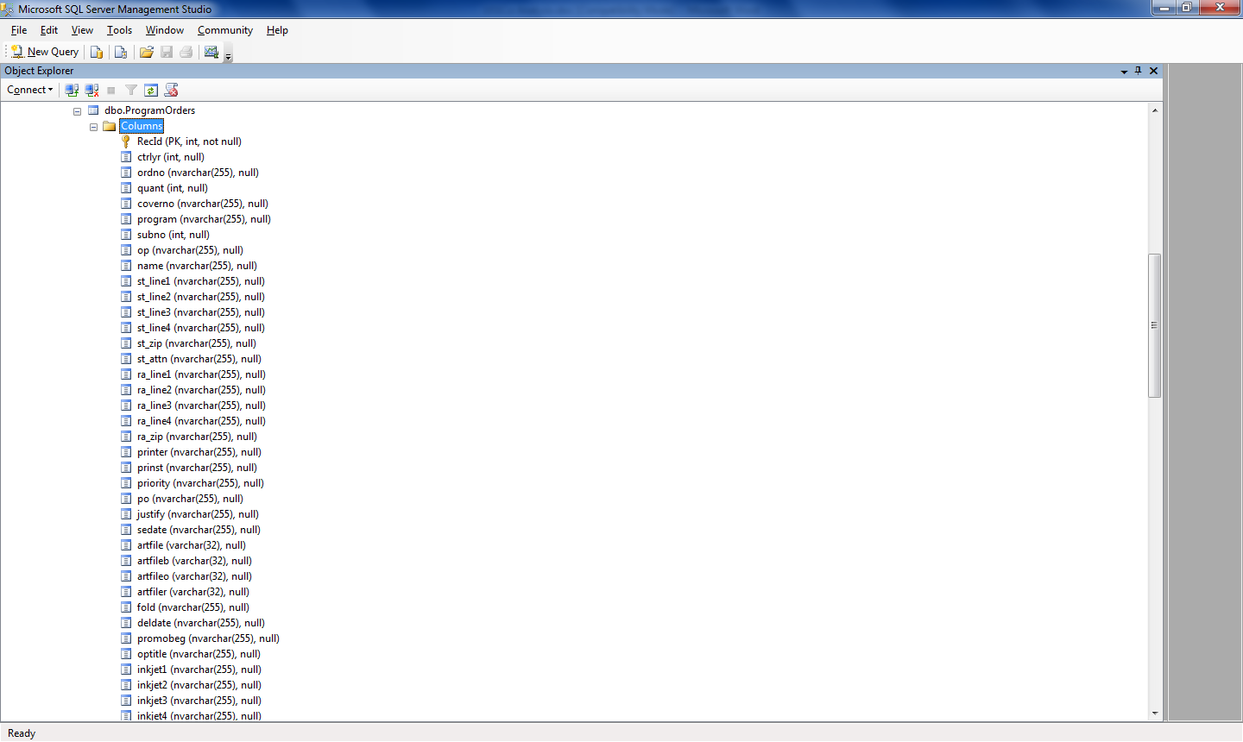
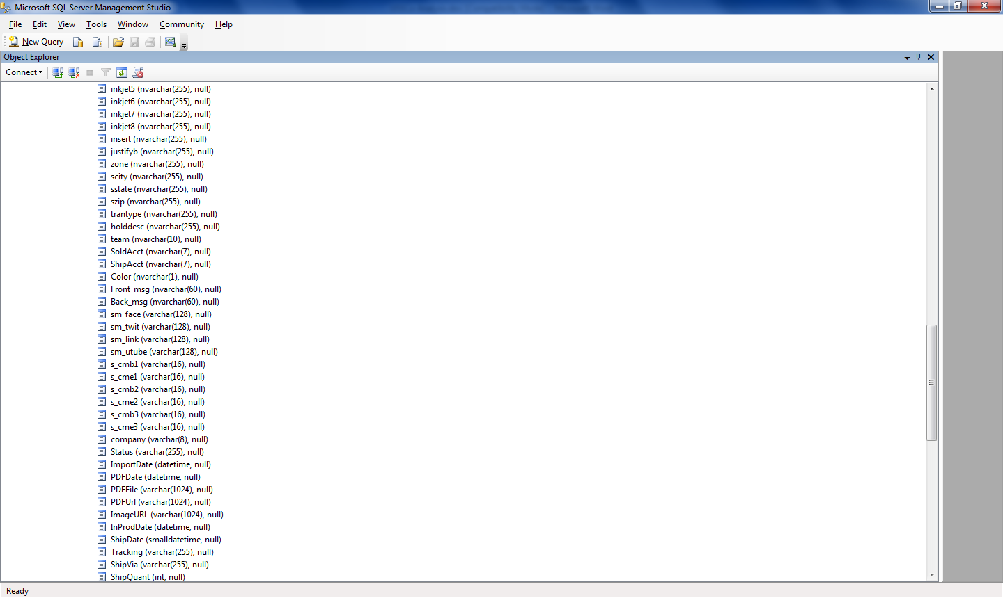
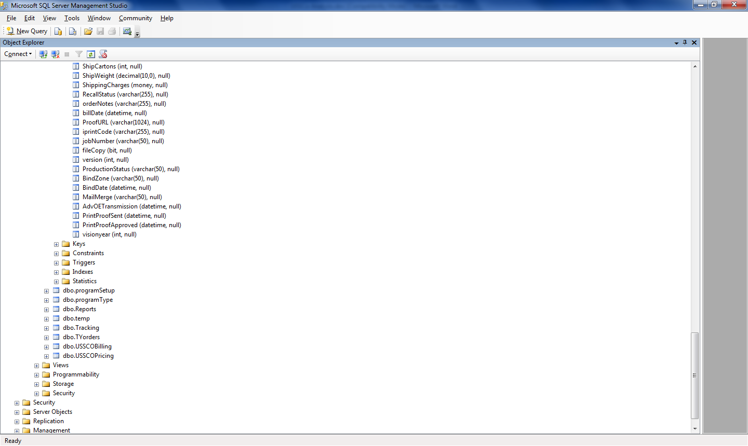
85 columns total for an Advoe or program order.
There are 3 databases which mean data is scattered everywhere.
Solution:
Consolidate all tables into one normalized database. This will allow quicker and easier data retrieval.
Searched fields are not index making the reads from the database slower which makes it almost impossible to make a responsive web page to display the data. God forbid Ussco ever wants to see every Program Order at once.
Frequently, we see dtOrders.Fill(ALL ORDERS) just to make a new record and update the table when an insert statement or update statement would increase efficiency of the program.
Conclusion:
In short the writers of the original Ussco code and iPrint code have proven that they write unmaintainable, anti-pattern loaded, almost un-modifiable, poor performing, non-scalable and insecure software. They have proven beyond a shadow of a doubt their inability to code and have left and dealt a large blow and been a detriment to Vision by allowing such software, without design or consideration for future development or other developers, to see the light of day. The cost of keeping the code as it is, is too high and given the fragile state of this procedural code, it is time to update it. Fixing said code will increase efficiency, performance, reduce future costs, current costs, and allow for easier future development for Ussco.
Thank you for reading.

